LAB 321 Assignment | Type: | Long Assignment
 | Code: | J3.L.P0001
 | LOC: | 200
 | Slot(s): | 8

Title: Online Quiz

Background

You often see and use the online test or quiz, it can be found easily on internet, training center, academy or even a school. In this assignment, you will learn how to build an online quiz system, particular system including the module for administrator (manager) uses to import/manage the question bank and user information, other module for taken test.

Program Specifications

Program an online quiz, detail functions of this website is described below

Features:
This website contains 5 main functions, we have two kind of users: Teacher and normal user.
As the teacher you are allowed to use all functions of system, for Manage Quiz – you only can see your created questions only.
As the Student you are allowed to use function 1, 2 and 5 only.
- Function 1 : Home page : ( see figure 01)
  - There for menu on navigation bar: Home (current page), Take Quiz, Make Quiz, Manage Quiz and Contact
  - To be able to use the function of each menu, users are required to login the system first. If you wish to have an account, you can make a new one by click on hyperlink Register
- Function 2 : Take Quiz page ( see PIC 02)
  - Select the number of questions and start the quiz
  - Assume that the time allowance for a question is 01 (one) minute
  - Calculate and print the score for taker
- Function 3: Make Quiz ( see PIC 03)
  - Enter information of a Quiz and save it to your database
- Function 4: Manage Quiz ( see PIC 04)
  - Display information of all questions
- Function 5: Register a new user ( see PIC 05)
  - Register a new user
  - A new user and be a teacher or normal user

Note: All data must be load from database, not hard code.

Expectation of User interface:

Pic 01: Home Page ( TOP)
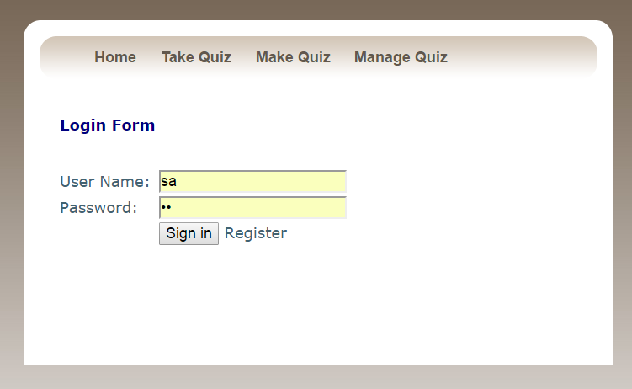

PIC 02: Take Quiz Page

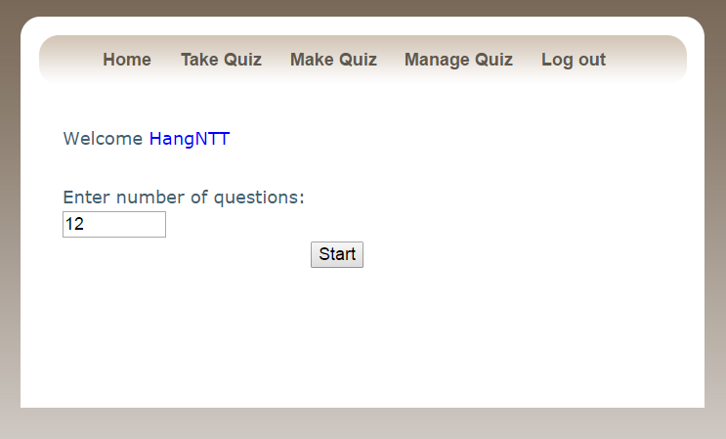
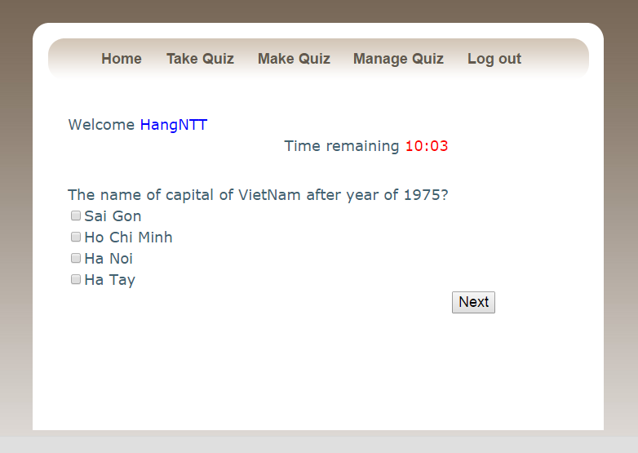

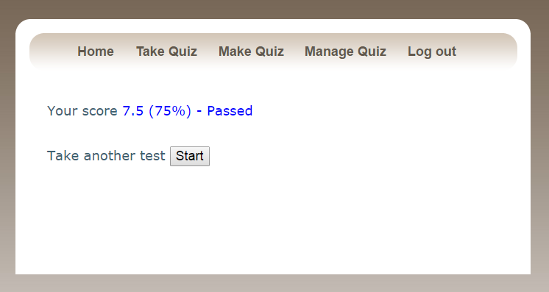

Pic 03: Make quiz page

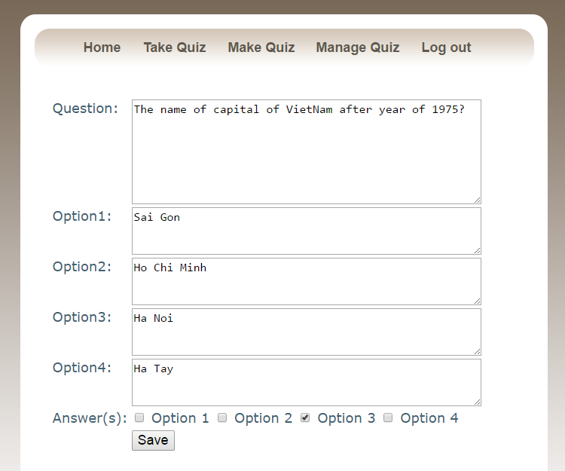

PIC 4: Manage Quiz Page
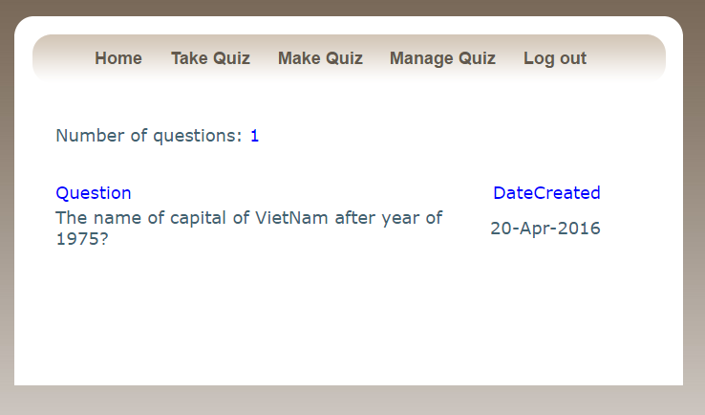
PIC 05: Register Page

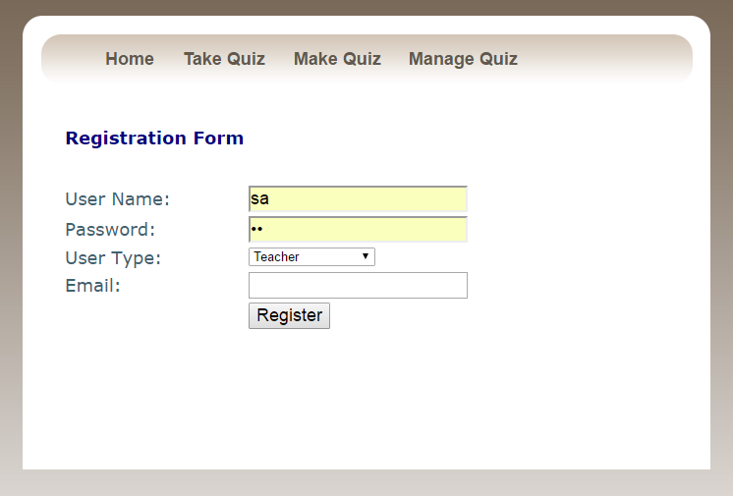

Guidelines
- Step 1 : Create prototype
- Step 2 : Design database base on created prototype
- Step 3 : Code & Test

